Ryder Elementary Fun Summer Reading 202014
2014-2015
PreK-2

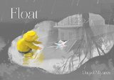
Float, by Daniel Miyares
A boy's small paper boat—and his large imagination—fill the pages of this wordless picture book, a modern-day classic from the creator of Pardon Me! that includes endpaper instructions for building a boat of your own.
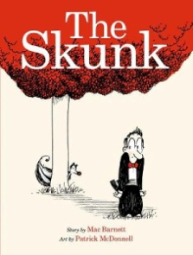
The Skunk, by Mac Barnett
When a skunk first appears in the tuxedoed man's doorway, it's a strange but possibly harmless occurrence. But then the man finds the skunk following him, and the unlikely pair embark on an increasingly frantic chase through the city, from the streets to the opera house to the fairground. What does the skunk want? It's not clear--but soon the man has bought a new house in a new neighborhood to escape the little creature's attention, only to find himself missing something. . .

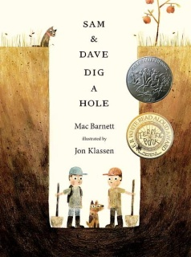
Sam and Dave Dig a Hole, by Mac Barnett
Sam and Dave are on a mission. A mission to find something spectacular. So they dig a hole. And they keep digging. And they find . . . nothing. Yet the day turns out to be pretty spectacular after all. Attentive readers will be rewarded with a rare treasure in this witty story of looking for the extraordinary -- and finding it in a manner you'd never expect.

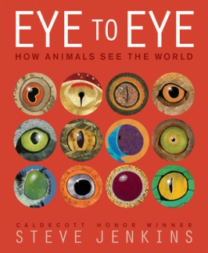
Eye to Eye, How Animals See the World, by Steve Jenkins
In his latest eye-popping work of picture book nonfiction, the Caldecott Honor–winning author-illustrator Steve Jenkins explains how for most animals, eyes are the most important source of information about the world in a biological sense. The simplest eyes—clusters of light-sensitive cells—appeared more than one billion years ago, and provided a big survival advantage to the first creatures that had them. Since then, animals have evolved an amazing variety of eyes, along with often surprising ways to use them.

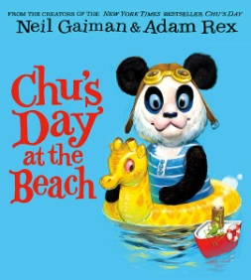
Chu’s Day at the Beach, by Neil Gaiman
"Chu and his family are going to the beach! Chu is excited. He will get to play in the sand and wade in the water. But what will happen if Chu sneezes at the beach? And what will happen if he doesn't?"--

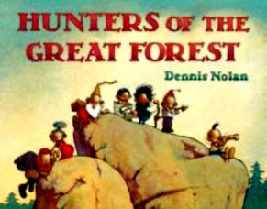
Hunters of the Great Forest, by Dennis Nolan
On a warm night, a band of hunters sets out on a journey. As they travel over hills, through thickets of trees, and around mountains, nothing will keep them from their ultimate goal. What that goal is may surprise you.
Dennis Nolan's remarkable, imaginative illustrations lead the way in this wordless picture book about an epic journey.

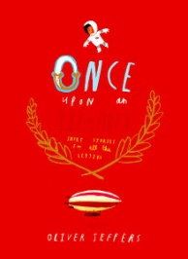
Once Upon an Alphabet: Short Stories for All the Letters, by Oliver Jeffers
The most inventive and irresistible book of the year spans a mere 26 letters (don't they all!) and 112 pages. From an Astronaut who's afraid of heights, to a Bridge that ends up burned between friends, to a Cup stuck in a cupboard and longing for freedom, Once Upon an Alphabet is a creative tour de force from A through Z. Slyly funny in a way kids can't resist, and gorgeously illustrated in a way readers of all ages will pour over, this series of interconnected stories and characters explores the alphabet in a way that will forever raise the bar.
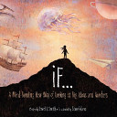
If: A Mind-bending New Way of Looking at Big Ideas and Numbers, by David J. Smith
Some things are so huge or so old that it's hard to wrap your mind around them. But what if we took these big, hard-to-imagine objects and events and compared them to things we can see, feel and touch? Instantly, we'd see our world in a whole new way." So begins this endlessly intriguing guide to better understanding all those really big ideas and numbers children come across on a regular basis.

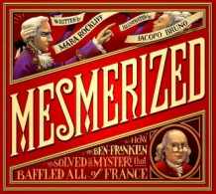
Mesmerized: How Ben Franklin Solved a Mystery That Baffled All of France, by Mara Rockliff
The day Ben Franklin first set foot in Paris, France, he found the city all abuzz. Everyone was talking about something new—remarkable, thrilling, and strange. Something called . . . Science!
But soon the straightforward American inventor Benjamin Franklin is upstaged by a compelling and enigmatic figure: Dr. Mesmer. In elaborately staged shows, Mesmer, wearing a fancy coat of purple silk and carrying an iron wand, convinces the people of Paris that he controls a magic force that can make water taste like a hundred different things, cure illness, and control thoughts! But Ben Franklin is not convinced. Will his practical approach of observing, hypothesizing, and testing get to the bottom of the mysterious Mesmer's tricks?

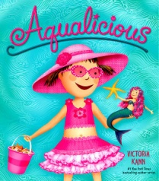
Aqualicious, by Victoria Kann
Pinkalicious and her family go on a trip to the beach for a day of sun, fun, and sand castles! The day gets even more exciting when Pinkalicious finds a mini-mermaid named Aqua while she's collecting shells. Aqua wants to find her way home, and Pinkalicious and Peter decide to help—after they show her all of the pinkamazing things to do at the seashore!

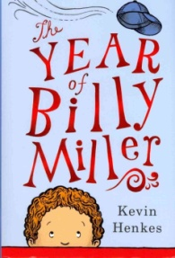
The Year of Billy Miller, by Kevin Henkes
Seven-year-old Billy Miller starts second grade with a bump on his head and a lot of worries, but by the end of the year he has developed good relationships with his teacher, his little sister, and his parents and learned many important lessons.

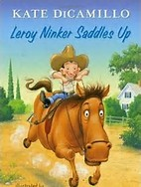
Leroy Ninker Saddles Up: Tales from Deckawoo Drive, by Kate DiCamillo
Leroy Ninker, the "reformed thief" from the Mercy Watson books, dreams of being a cowboy. "Every cowboy needs a horse," so he purchases "old but good" and "very exceptionally cheap" Maybelline. Unfortunately, acquiring a horse and keeping one turn out to be two different challenges, but Leroy rises to the occasion.
Classic Chapter Books
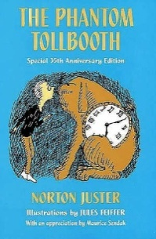
The Phantom Tollbooth, by Norton Juster
Milo finds himself in a world of comical chaos after he drives through a mysterious tollbooth that appears in his room. Juster's marvelous wordplay and humor make this a delightfully wise and funny story, published here in a thirty-fifth anniversary edition featuring an appreciation by Maurice Sendak.

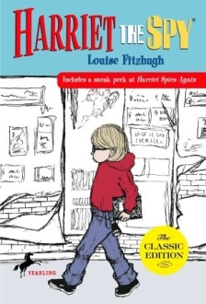
Harriet the Spy , by Louise Fitzhugh
Using her keen observation skills, 11-year-old Harriet M. Welsch writes down in her notebook what she considers the truth about everyone in and around her New York City neighborhood. When she loses track of her notebook, it ends up in the wrong hands, and before she can stop them, her friends read the sometimes awful things she's observed and written about each of them.
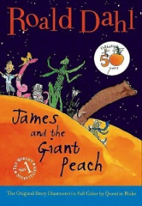
James and the Giant Peach, by Roald Dahl
A young boy escapes from two wicked aunts and embarks on a series of adventures with six large insects he meets inside a giant peach.

Don’t forget to visit the Community Library in Cobleskill for lots of fun summer reading events!

List compiled by Mrs. Shoudy. Annotations from Amazon and Follett.

